July 24, 2025

The Honorable Christian McDaniel, Co-Chairman

The Honorable Jason Petrie, Co-Chairman

Interim Joint Committee on Appropriations and Revenue

Legislative Research Commission

Capitol Annex

Frankfort, Kentucky 40601

Dear Senator McDaniel, Representative Petrie and Members of the Committee:

Pursuant to Part III, subsection 22, of House Bill 6, from the 2024 Regular Session, I am reporting the certified undesignated balance for the end of fiscal year 2024-2025 to be $506,373,253 for the General Fund and $61,645,556 for the Road Fund.

Also pursuant to Part III, subsection 22, of House Bill 6, from the 2024 Regular Session, the State Budget Director, John Hicks, has determined the amount for the General Fund to be designated and carried forward for budgeted purposes in fiscal year 2025-2026 is $192,900,746, and the amount of the Road Fund to be designated and carried forward for budgeted purposes in fiscal year 2024-2025 is $0.

Pursuant to Part III, subsection 22, and Part VII, subsection 2, of House Bill 6, from the 2024 Regular Session, the amount of the actual General Fund undesignated fund balance for the General Fund Surplus Account that may be available for expenditure pursuant to the General Fund Surplus Plan is $313,472,507.

Sincerely,

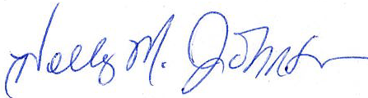

Holly M. Johnson

Secretary

cc: John Hicks, State Budget Director

Joe McDaniel, Controller